**ShopBridge Testing Screenshots**

**1.Get All Products**

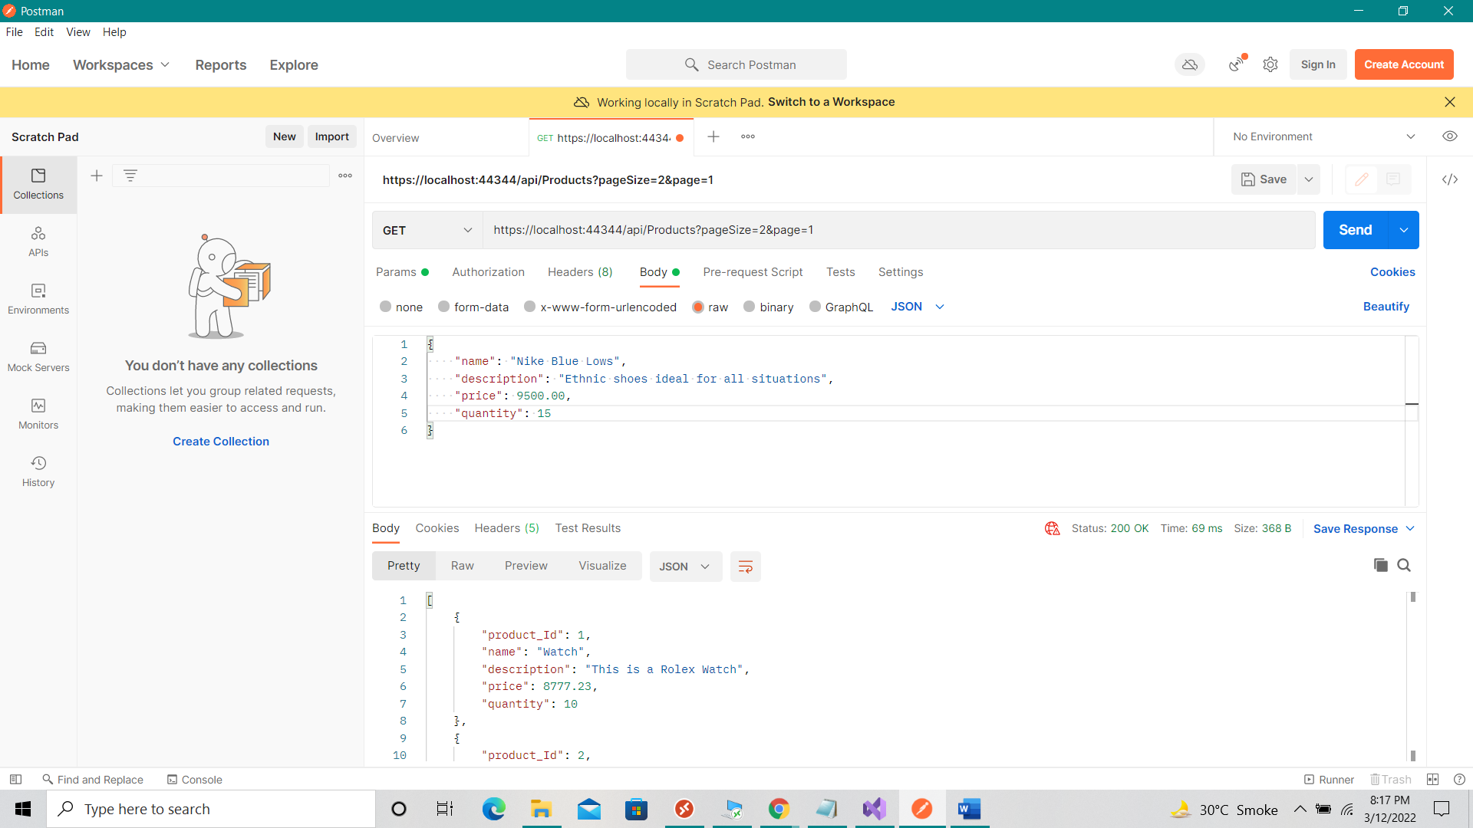

**Note:** If user wants to view all products in the store then replace url in the screenshot with “{[baseUrl}/api/Products](https://localhost:44344/api/Products)” where baseUrl is the Url where service is hosted.

**2.Add Product**

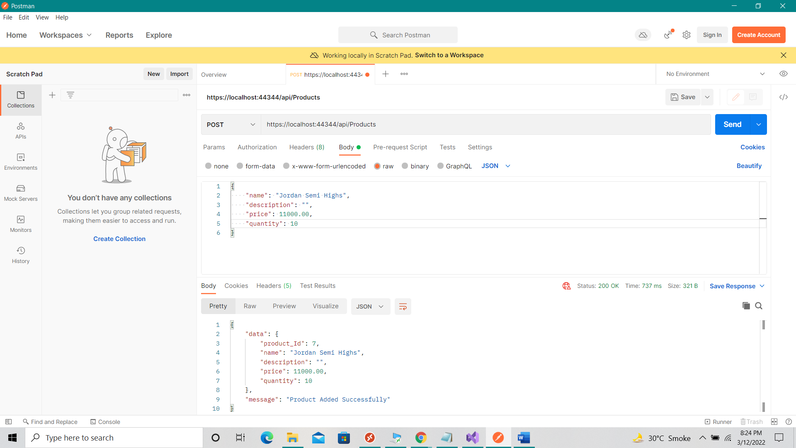

**3.Update Product**

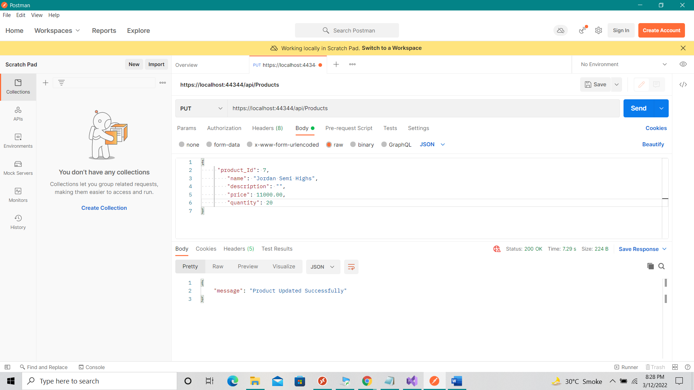

**4.Delete Product**

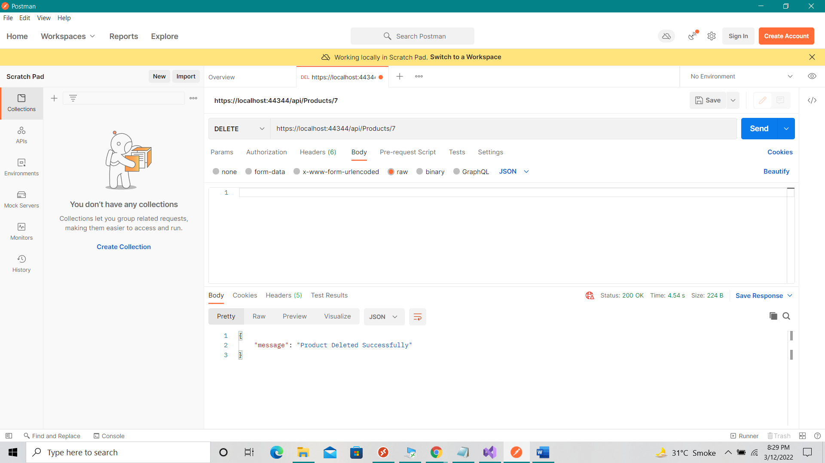

**5.Get Product By Id**

